April 2024 School Newsletter

Your MHRSB Has a New Look!

We're thrilled to announce that the Mental Health & Recovery Services Board of Allen, Auglaize, and Hardin Counties has a new look!

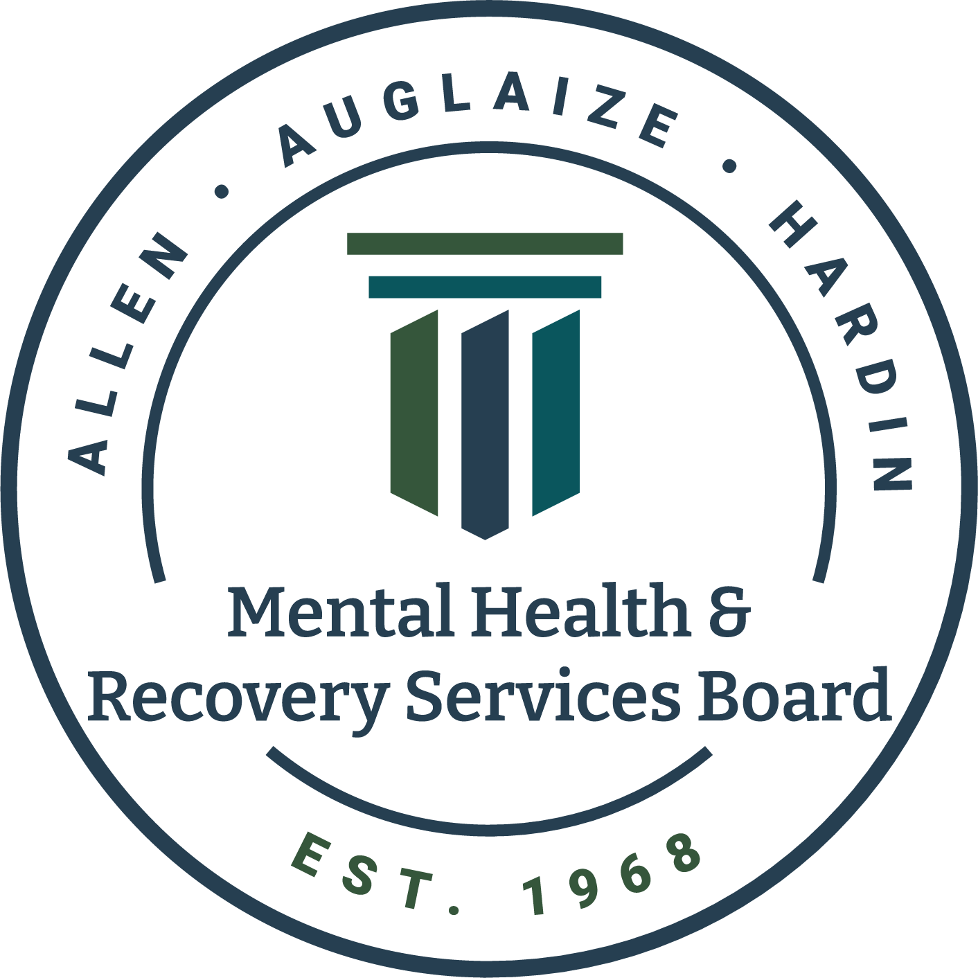
Though the Board’s appearance is changing, our commitment to serving our community remains steadfast. Over the past fifty years, we've adapted our services to better meet the needs of those we serve. In light of these developments and our ongoing dedication to behavioral health, we felt it was time to redefine our identity through a fresh logo and renewed mission.

Empowering Mental Health & Recovery Since 1968—at the heart of our mission lies a legacy of support and empowerment. For over five decades, the Mental Health Recovery Services Board (MHRSB) has been dedicated to the residents of Allen, Auglaize, and Hardin Counties.

Our three pillars, Prevention, Treatment and Recovery, form the cornerstone of our commitment. Prevention involves empowering residents in need with knowledge to safeguard their mental well-being. When treatment is required, MHRSB provides access to tailored resources. Recovery is our ultimate goal—ensuring residents get the help they need.

Together, we are dedicated to empowering residents with the tools and assistance for their path to recovery.

You can still find us at all the same places on Facebook, Instagram, YouTube, and online at wecarepeople.org or mhrsb.org.

MHRSB can be reached at 419-222-5120, and our office is located at 528 W. Market St., Lima, OH 45801.

Substance Use & Vaping Among Youth

1 in 5 young adults vape. While high school students' use of tobacco products dropped from 16.5% in 2022 to 12.6% in 2023 nationally, middle school students experienced an increase from 4.5% to 6.6% in that same time frame. Vapes continue to be the most commonly used tobacco product among middle and high school students.

MHRSB has many local agencies and programs to help prevent substance use and vaping among youth.

CATCH My Breath is a youth e-cigarette prevention program that equips students with the knowledge and skills to make informed decisions about the use of e-cigarettes. It is for grades 6-12 and is run through PASS.

Class Action is an evidence-based alcohol-use prevention program. This program uses real-world social and legal consequences of underage alcohol use to educate teenagers. This program is also through PASS for grades 9-12.

I Mind is a newer, innovative local program funded by the MHRSB. It gives adolescents tools to avoid substance use through a voluntary one-day, four-hour class for grades 7-12. If parents suspect their child is using substances, they can refer their child to the program. Learn more at wecarepeople.org/imindprogram.

Parents play the most significant role in preventing their children from using substances. Talking to your child about substances is necessary, but it can be overwhelming to know where to start.

Listen like a friend but respond like a parent. Here are some tips:

- Start conversations in low-pressure spaces where direct eye contact is not the priority. This can be in car rides, while doing chores, or when going for a walk together.
- Keep your conversations in the present tense. For kids and teens, the future can feel a long way off.
- Talk about how using drugs, alcohol, and vaping can spoil the fun of school, after-school activities, and friends.
- Practice with them on what to say if someone offers them substances.
- Show love and give praise. Your child needs to hear the good stuff, too.

Learn more at wecarepeople.org/letstalk.

If you are worried about your child, call the local 24/7 crisis line at 1-800-567-HOPE (4673) or call 988. If you are looking for other local resources, call 211.

